Concurrency
PRJ311 – workshop1:
Create the form like below:
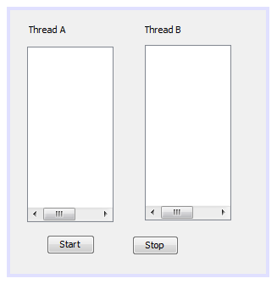
Create 2 threads A and B, which work in collaboration with each other as follows:
When the button “Start” is clicked, the thread B comes to “wait” state. Thtread A creates a random number and add to the text area A, then notify the thread B. The thread B then add this number to the text area B and notify the thread A to create a new random number,… and continue like that.
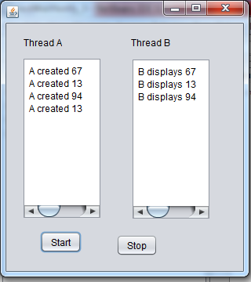

PRJ311 – workshop2:
Design a class named MyQueue for storing integers. In the MyQueue class, the elements are retrieved in a first-in first-out (FIFO) fasion, so that we call it a queue (Queue is such a data structure, which processes elements by FIFO fashion). The class contains:
The array Integer [] a that stores values in the queue.
A data field named max that stores the size of the array a.
A data field named n that stores the number of elements in the queue.
A constructor that creates a MyQueue object with default capacity 8
The following methods are also included in the queue:
void put(Integer x) - add x to the queue
Integer get() - remove and return the element from the queue (a[0]).
isEmpty() - return true if the queue is empty
int getSize() - return the size of the queue
void traverse() - display on the screen all elements of the queue, from a[0] to a[n-1].

Implement Producer Consumer design Pattern in Java using wait, notify methods in Java.
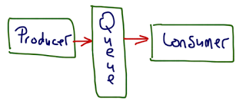
At first a queue is created and some integer values are put into the queue. After that the producer and consumer start to work as follows:
The producer create 10 random number and put them to the queue. Each time the producer put one number to the queue, it must wait until the consumer gets 1 number from the queue and displays it on the screen. At design the form looks like:

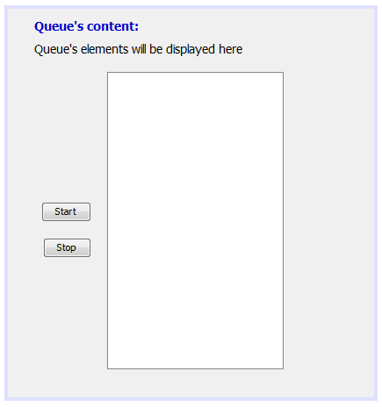
At running the output looks like:
